GOVERNMENT OF INDIA
Ministry of Commerce & Industry | NICDC
Industrial Corridor Project Management System (IC-PMS)

MODULE 5
Contract &
Procurement Management
GFR 2017 / CVC / GeM / CPPP Aligned End-to-End Contract Lifecycle
Detailed Design Document

Document Version: 1.0 | March 2026 | Classification: Restricted
Prepared by: IC-PMS Solution Architect Team | NICDC / Ministry of Commerce & Industry

1. Module Overview

1.1 Purpose & Objectives
Module 5 — Contract & Procurement Management — governs the complete lifecycle of every contract on India's industrial corridor programme, from the initial procurement plan through tender preparation, bid management, contract award, execution monitoring, variation order management, contractor performance scoring, dispute resolution, and final account settlement. It is the module that translates the physical programme (WBS in Module 1) into legally binding commercial relationships with contractors, consultants, and suppliers.
The module is designed in full compliance with the Government of India's General Financial Rules 2017 (GFR), Central Vigilance Commission (CVC) guidelines, and the Central Public Procurement Portal (CPPP) framework. It integrates with the Government e-Marketplace (GeM) for direct procurement, and with Module 4 (Cost Management) for LOA value commitment, payment scheduling, and VO budget impact. The contract lifecycle management model draws on Oracle Primavera Unifier's Contract Manager business process framework.
A distinctive feature of Module 5 is its Integrity Pact management capability — mandatory for all contracts above ₹10 Crore as per CVC guidelines — which tracks Integrity Pact signatures, potential breach events, and Independent External Monitor (IEM) appointments. The module also hosts a contractor performance scorecard system that generates monthly ratings across quality, safety, schedule, environmental compliance, and payment conduct — feeding into a contractor blacklisting register aligned with Ministry of Finance debarment rules.

1.2 Module Scope
Capability | Included | Regulatory Reference
Procurement plan creation & approval (WBS-linked) | Yes | GFR Rule 144 — Commitment authorisation
NIT / ITB preparation and document generation | Yes | GFR Rule 149 / CPWD Works Manual
e-Procurement publication (CPPP integration) | Yes | GFR Rule 158 — Mandatory e-publishing
GeM portal integration (direct procurement) | Yes | GFR Rule 149A — GeM preference policy
Bid receipt, technical & financial evaluation | Yes | GFR Rule 175 — Evaluation methodology
Comparative Statement (CS) generation | Yes | CPWD Works Manual — CS format
Integrity Pact management (CVC guidelines) | Yes | CVC OM No. 04-03-00-CTE-9 (2007)
Negotiation minutes and L1 confirmation | Yes | GFR Rule 175 — L1 negotiation
LOA / Contract award and execution | Yes | GFR Rule 149 — Contract conditions
Contractual milestone tracking | Yes | Primavera Unifier Contract Manager
Variation Order lifecycle (types, approvals, GFR limits) | Yes | GFR Rule 209
Sub-contractor management | Yes | Contract sub-letting clause — NIT conditions
Contractor performance scorecard (8 KPIs) | Yes | IC-PMS Innovation — NICDC requirement
Dispute & arbitration register | Yes | Arbitration & Conciliation Act 1996
Bank Guarantee tracking and alerts | Yes | Contract conditions / GFR Rule 235
Defect Liability Period (DLP) and retention management | Yes | Contract conditions / GFR Rule 209
Final account settlement | Yes | CPWD Works Manual — Final Bill procedures

1.3 Key Design Principles
- GFR-first procurement: All procurement method selections (OCT, LTE, GeM, Nomination) are governed by GFR thresholds; the system enforces the correct method based on estimated contract value
- Transparency by design: Every bid evaluation, committee decision, and award recommendation is logged with user ID, timestamp, and justification — CVC-grade audit trail from NIT to LOA
- Integrity Pact enforcement: For contracts above ₹10 Cr, the Integrity Pact is a mandatory document; system blocks LOA issuance until IP is signed by both bidder and designated NICDC officer
- Primavera Unifier alignment: Contract types, milestone definitions, VO workflows, and final account processes mirror Oracle Primavera Unifier's Contract Manager for data model interoperability
- Performance drives payment: Contractor performance scorecard feeds directly into payment processing (Module 4); poor safety/quality scores can trigger PMC review before bill approval
- Single contract record: Every LOA, WO, amendment, VO, and correspondence is stored under a single contract record — eliminating the risk of parallel paper-and-digital tracking

2. Sub-Functions — Detailed Requirements

2.1 Sub-Function 5.1 — Procurement Planning
Procurement Planning is the strategic front-end of the contract lifecycle. It translates the WBS work packages (from Module 1) into a structured procurement plan — identifying what needs to be procured, through which method, by when, at what estimated value, and with which contract type. An approved procurement plan is the mandatory precondition for initiating any tender process.

Functional Requirements
- Procurement plan linked to WBS: Each WBS work package (Level 5 and below) generates a procurement plan entry; packages may be bundled (e.g., two small works combined) or split (e.g., phased procurement)
- Procurement method selection: Automated method recommendation based on estimated contract value and GFR thresholds, with override requiring documented justification and approval
- Contract type selection: Works Contract (CPWD/FIDIC), Supply Contract, Consultancy Agreement, Turnkey/EPC, PPP Concession — each with different bid documents, conditions of contract, and evaluation methodology
- Annual procurement calendar: All planned tenders for the financial year displayed as a calendar view; NIT publication dates, bid due dates, and award target dates mapped to the project schedule
- Bundling and splitting: PMC or SPV PM can bundle multiple small WBS packages into a single tender (reducing procurement cost) or split a large package into multiple tenders (increasing competition)
- Procurement approval: Procurement plan submitted by SPV PM → approved by SPV Director → NICDC concurrence for packages above ₹50 Cr → Ministry approval for packages above ₹500 Cr
- Pre-qualification: For large complex contracts (typically > ₹100 Cr), a Request for Qualification (RFQ) stage prior to ITB — managing shortlisted qualified bidders list

Procurement Method Thresholds (GFR 2017)
Method | GFR Rule | Value Threshold | Conditions
GeM Portal (Direct Order) | Rule 149A | Up to ₹50 Lakh (Works); Higher with approval | Preferred for goods/services on GeM; direct ordering
Limited Tender Enquiry (LTE) | Rule 152 | Up to ₹25 Lakh | Min. 3 quotations; list of empanelled vendors
Open Competitive Tender (OCT) | Rule 149 | Above ₹25 Lakh (Works) | CPPP publication mandatory > ₹2 Cr; IP > ₹10 Cr
Single Source / Nomination | Rule 154 | Any value; special conditions | Cabinet/CCEA approval; documented justification
Expression of Interest (EOI) | Rule 160 | Typically > ₹100 Cr complex works | Pre-qualification before full tender
Design-Build (FIDIC Yellow) | Rule 149 | Any value | Additional technical capacity qualification required

2.2 Sub-Function 5.2 — Tender Preparation
The Tender Preparation sub-function provides a structured document assembly environment for creating complete, GFR-compliant tender packages — including Notice Inviting Tender (NIT), Instructions to Bidders (ITB), Conditions of Contract, Bill of Quantities (BOQ), Technical Specifications, and Drawings Register. All documents are version-controlled and stored in Module 6 DMS.

Functional Requirements
- NIT auto-generation: System generates a standardised NIT document from template (incorporating NICDC letterhead, tender number, scope summary, estimated value, bid security, completion period, eligibility criteria) — with editable fields for package-specific content
- BOQ builder: Line-item BOQ linked to CPWD SOR 2024-25 / MoRTH specifications / State PWD DSR for Works contracts; quantity cells editable; unit rates pre-filled from SOR with override capability
- Technical specification library: Reusable specification clauses (CPWD, IRC, IS codes) maintained in a specification library; clauses selected and assembled into package-specific specification document
- Eligibility criteria wizard: Turnover criteria, similar work experience criteria, personnel qualification requirements — configurable per contract type with GFR-mandated minimum criteria pre-set
- Bid security (EMD): System computes EMD amount (typically 2% of estimated value, capped at ₹1 Cr as per GFR Rule 166); modes: DD, BG, e-Payment via PFMS
- Pre-bid meeting management: Pre-bid meeting scheduled, minutes recorded in system, pre-bid queries logged and responses issued as Amendment/Corrigendum to tender
- Corrigendum management: Any post-publication changes to tender documents issued as numbered corrigenda; all registered bidders auto-notified; corrigendum auto-attached to tender package on CPPP
- Document hash: All tender documents given SHA-256 hash on publication; hash recorded in system for integrity verification — any tampering post-publication is detectable

2.3 Sub-Function 5.3 — Bid Management
The Bid Management sub-function manages the complete bid lifecycle — from publication through receipt, technical evaluation, financial evaluation, comparative statement, integrity pact verification, negotiation, and final award recommendation. The process is fully electronic, with sealed bid envelopes handled through CPPP's secure two-envelope / three-envelope system.

Bid Evaluation Process
- Publication: NIT published on CPPP and NICDC website simultaneously. GeM orders placed via GeM API for eligible items. Tender documents available for download against EMD payment.
- Bid Receipt: Bids submitted electronically via CPPP up to the due date and time. System records exact submission timestamp. Late bids automatically rejected without opening. Bid opening committee constituted and recorded.
- Technical Evaluation: Bids opened technically; evaluated against eligibility criteria — turnover, similar work experience, key personnel CVs, equipment list, bank solvency certificate. Scoring matrix applied. Technically qualified (TQ) / Not Qualified (NTQ) determination recorded with justification for each bidder.
- Integrity Pact Verification: For contracts above ₹10 Cr — Integrity Pact signed by each bidder checked against the IP register. Any bidder who has not signed or has a pending breach investigation is flagged; system holds their financial bid unopened pending resolution.
- Financial Evaluation: Financial bids of TQ bidders opened. L1 (lowest responsive bidder) identified. Comparative statement generated showing all bids ranked. If L1 bid is above estimated cost, negotiation with L1 may be conducted (documented in system).
- Award Recommendation: Award recommendation report prepared — summarising tender process, evaluation methodology, TQ/NTQ decisions, IP status, CS, negotiation outcome, and recommended L1 contractor. Report submitted through tiered approval workflow.
- LOA Issuance: On approval, Letter of Award generated from template and digitally signed (DSC). LOA transmitted to L1 contractor via CPPP and registered email. Contract execution (Module 5.5) initiated.

Evaluation Criteria Framework
Criteria Category | Weight | Sub-Criteria | Minimum Threshold
Financial Capacity | 30% | Annual Turnover (last 3 years); Net Worth; Solvency certificate | Turnover ≥ 3× estimated annual contract value
Technical Experience | 40% | Similar works (value, scope, geography); Works in progress | 1 similar work ≥ 50% of estimated value in last 7 years
Key Personnel | 15% | Project Manager (18yr exp), Resident Engineer (10yr exp), QC Engineer (8yr exp) | All key posts with minimum qualification and experience
Equipment | 10% | Critical equipment availability (owned + leased) | Key equipment: Batching plant, cranes, paver, excavators
Safety Record | 5% | Fatal accident rate; Safety certifications (OHSAS 18001) | No fatal accidents on GoI contracts in last 3 years

2.4 Sub-Function 5.4 — Contract Award & LOA Management
On approval of the award recommendation, the Contract Award sub-function formalises the commercial relationship — generating and issuing the Letter of Award (LOA), recording the Contract Master record, and initiating the post-award onboarding workflow including Performance Security submission, Integrity Pact execution, and advance payment processing.

Functional Requirements
- LOA generation: Auto-generated from standard NICDC LOA template incorporating: Contract number, WBS scope, LOA value, Completion period, Defect Liability Period, Liquidated Damages rate, Performance Security requirement, Milestone payment schedule, Special conditions
- Contract Master creation: LOA award triggers creation of Contract Master record (D4) as the definitive record of the contract — source of truth for all billing, VO, and performance tracking
- Performance Security: Contractor required to submit PBG (typically 5% of LOA) within 28 days of LOA; system tracks PBG submission status; advance payment blocked until PBG received
- Advance payment processing: Mobilisation advance (up to 10% of LOA per GFR Rule 236) and Material advance (against material at site) processed through Module 4 once BG received
- GeM order linkage: For procurement through GeM, the GeM order reference number linked to Contract Master; delivery tracking feeds Module 4 payment trigger
- Unsuccessful bidder notification: System auto-generates rejection letter to unsuccessful bidders on LOA issuance; EMD refund instructions triggered
- LOA acceptance: Contractor acknowledgement of LOA recorded in system (digital acknowledgement or scanned signed copy); timeline for PBG submission starts from LOA acceptance date

2.5 Sub-Function 5.5 — Contract Execution Monitoring
Contract Execution Monitoring tracks the day-to-day performance of each active contract against its contractual obligations — milestones, progress, quality, safety, and financial compliance. It provides the PMC and SPV PM with real-time contract health dashboards and generates contractual notices (show-cause, LD, suspension) through structured workflows.

Functional Requirements
- Contractual milestone register: All milestones from the LOA payment schedule registered as trackable events with baseline dates, forecast dates, completion evidence requirement, and payment linkage
- Progress reporting: Contractor submits weekly progress report via IC-PMS portal; report format standardised (activities, resources deployed, issues); PMC reviews and certifies/disputes each week
- Site instruction management: PMC can issue numbered Site Instructions (SI) to contractor for day-to-day field instructions; contractor required to acknowledge and confirm compliance date
- Quality register: Non-Conformance Reports (NCRs) raised by PMC against defective work; contractor response, rectification, and PMC re-inspection recorded; open NCRs block Final Bill processing
- Safety incident register: All safety incidents (near-miss, minor injury, major injury, fatal) logged; NICDC Safety Officer automatically notified; incident investigation and closure tracked
- Liquidated Damages computation: If contract completion forecast extends beyond the Scheduled Completion Date, system auto-computes LD liability (LOA value × LD rate per day × delay days) — deducted through Module 4 billing
- Contractual correspondence: All formal notices — Show Cause Notice (SCN), Extension of Time (EOT), Termination Notice — prepared from template, digitally signed, and served via registered email with delivery confirmation
- Sub-contractor register: All sub-contractors notified by main contractor registered in system; PMC approves sub-contractors; sub-contractor scope and value tracked for sub-letting limit compliance

2.6 Sub-Function 5.6 — Variation Order Management
Variation Order management is covered in full detail in Module 4 (Section 2.6) from a financial perspective. Module 5 manages the contractual initiation, rate justification, and approval chain for VOs — feeding the approved VO values to Module 4 for budget commitment. Key additional requirements from the contract management perspective are described here.

Additional Contract-Specific VO Requirements
- VO initiation: VOs can be initiated by PMC (for site issues), SPV PM (for design changes), or contractor (for unforeseen conditions); all initiations captured with initiating party and reason code
- Rate analysis: For Extra Items, full rate analysis prepared in system — DSR base rate, add-ons for overhead and profit (per CPWD norms), site factor — with supporting quotation documents uploaded
- GFR 10% ceiling tracking: System maintains a running total of all VOs per contract as % of original LOA value; alert at 8%; workflow escalation at 10% before any further VO can be approved
- VO timeline: VOs must be approved before the work covered by the VO is executed; retrospective VOs flagged as irregular; Emergency VO ratification within 7 days required
- VO register export: Complete VO register exportable for NICDC quarterly VO review meeting and CVC tender scrutiny

2.7 Sub-Function 5.7 — Contractor Performance Scorecard
The Contractor Performance Scorecard is an IC-PMS innovation — a monthly multi-dimensional rating of every active contractor across eight performance dimensions. The scorecard provides an objective, data-driven basis for performance improvement discussions, payment decisions (in combination with Module 4), and ultimately for maintaining NICDC's approved vendor list and debarment register.

Scorecard KPI Framework
KPI Dimension | Weight | Data Source | Scoring Method | Green Threshold
Quality Compliance | 20% | PMC NCR register — Open NCRs vs. Bills processed | 100 – (Open NCRs × 5); floor at 0 | Score ≥ 80 (≤ 4 open NCRs per bill)
Schedule Performance | 20% | Module 2 SPI for contractor's WBS packages | SPI × 100 (capped at 100) | Score ≥ 80 (SPI ≥ 0.80)
Safety Record | 20% | Safety incident register — LTIFR calculation | 100 – (Fatal×30) – (Major×10) – (Minor×2); floor 0 | Score ≥ 90 (zero fatal, < 2 minor)
Payment Compliance | 15% | Module 4 — RA Bill submission timeliness | 100 – (Avg days late × 5); capped at 100 | Score ≥ 85 (< 3 days late average)
Reporting Timeliness | 10% | Weekly progress report submission rate | % of reports submitted on time × 100 | Score ≥ 90 (≥ 9/10 reports on time)
Environmental Compliance | 8% | MoEFCC / NICDC site audit findings | 100 – (Major finding×15) – (Minor×5) | Score ≥ 85 (no major findings)
Resource Mobilisation | 4% | Module 2 EDI vs. contracted resource schedule | Actual Equipment Count / Planned × 100 | Score ≥ 80 (≥ 80% deployed)
Dispute Conduct | 3% | Dispute register — frivolous claims ratio | 100 – (Frivolous claims / Total claims × 100) | Score ≥ 90 (< 10% frivolous)

Scorecard Actions by Rating
Overall Score | Rating | Action | Module 4 Impact
90–100 | Excellent | Commendation letter; priority shortlisting for future tenders | No impact on payment
80–89 | Good | Monthly review — maintain performance | No impact on payment
70–79 | Satisfactory | Improvement Notice with targets for next month | No impact on payment
60–69 | Poor | Show Cause Notice; NICDC Director review meeting within 14 days | PMC may recommend payment hold on next RA Bill
50–59 | Very Poor | Warning of debarment; 30-day improvement plan mandated | RA Bill approval requires SPV Director sign-off
Below 50 | Critical — Debarment Risk | NICDC MD escalation; contract termination evaluation; debarment register entry | Invoice approval frozen; NICDC Finance Director must override

2.8 Sub-Function 5.8 — Final Account & Contract Closeout
The Final Account and Contract Closeout sub-function manages the financial and contractual closure of every completed contract — certifying the final value, releasing retention, confirming DLP obligations, settling disputes, and archiving the complete contract record for 30-year statutory retention.

Functional Requirements
- Final Measurement: PMC conducts final measurement of all executed quantities; final certified quantities entered in system; comparison with original BOQ and all approved VOs shows final scope
- Final Bill: Contractor submits Final Bill based on final certified quantities; System verifies all preceding RA Bills are paid and reconciled; Final Bill goes through the same satellite gate + PMC certification + approval workflow as regular RA Bills
- Final Account: System generates Final Account statement — original LOA + all VOs – all previous payments = Final Amount Due. Signed by contractor and NICDC as the definitive settlement
- No Claim Certificate (NCC): Contractor issues NCC confirming acceptance of Final Account and waiver of all further claims; NCC uploaded to DMS and linked to contract master
- Retention Release: On DLP completion and absence of outstanding defects, system triggers retention release workflow — PMC certifies DLP completion, SPV Director approves, Module 4 releases retained amount through PFMS
- Performance BG Release: PBG released after Final Account settlement and NCC receipt; BG register updated
- Dispute Settlement: All open disputes must be resolved (settled, arbitration award accepted, court judgement) before contract can be marked Closed; dispute register updated with resolution terms
- Contract archival: Closed contract record archived to Module 6 DMS with all documents (LOA, VOs, RA Bills, Final Account, NCC, correspondence); contract marked Closed in D4; 30-year retention policy applied

3. Data Flow Diagrams

3.1 DFD Level 0 — Context Diagram
The Context Diagram shows Module 5 as the Contract & Procurement Engine (Process 5.0) receiving WBS package definitions from Module 1, LOA values feeding into Module 4, bids from contractors, and publishing tenders to GeM/CPPP. It feeds contract data back to Module 4 (commitment values), Module 6 (document storage), and upstream to SPV/NICDC for approvals.
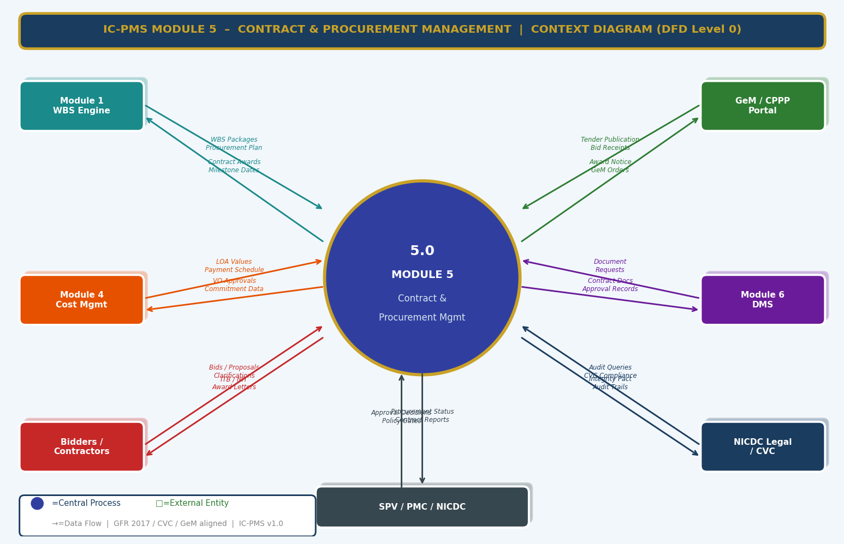
Figure 3.1 — DFD Level 0: Module 5 Context Diagram (GeM/CPPP, WBS, Cost, DMS, Contractor, Legal Flows)

External Entity Data Flow Summary
External Entity | Inputs to Module 5 | Outputs from Module 5
Module 1 — WBS Engine | WBS work packages for procurement, Estimated contract values from budget nodes, Package scope and geography | Procurement plan confirmation, Contract awards linked to WBS, Milestone dates for schedule integration
GeM / CPPP Portal | Bid responses from registered vendors, GeM order confirmations, Corrigendum acknowledgements | NIT publication, Bid documents, GeM purchase orders, Award notices
Module 4 — Cost Management | LOA value confirmation for commitment accounting, VO approvals for budget impact | Payment schedule by milestone, Commitment data, VO values for budget, Advance payment requests
Module 6 — DMS | Document requests, Approval record references | Contract documents (LOA, NIT, BOQ, VOs), Integrity Pact records, Audit trail, Correspondence log
Bidders / Contractors | Technical and financial bids, Pre-bid queries, Performance BG, Signed Integrity Pact | ITB/NIT documents, Corrigenda, LOA / Rejection letter, Site instructions, Contractual notices
NICDC Legal / CVC | Integrity Pact compliance requirements, Audit queries, CVC inspection findings | IP register, CVC compliance reports, Evaluation committee records, Blacklist status
SPV / PMC / NICDC | Approval decisions on award, EOT requests, VO approvals, Scorecard reviews | Award recommendation reports, Contract status dashboards, Performance scorecard, Final accounts

3.2 DFD Level 1 — Main Processes & Data Stores
The Level 1 DFD shows eight core contract management processes and eight data stores covering the full contract lifecycle from procurement planning through final account. The processes are sequential in the primary contract lifecycle direction, with performance monitoring and VO management as ongoing parallel processes during execution.
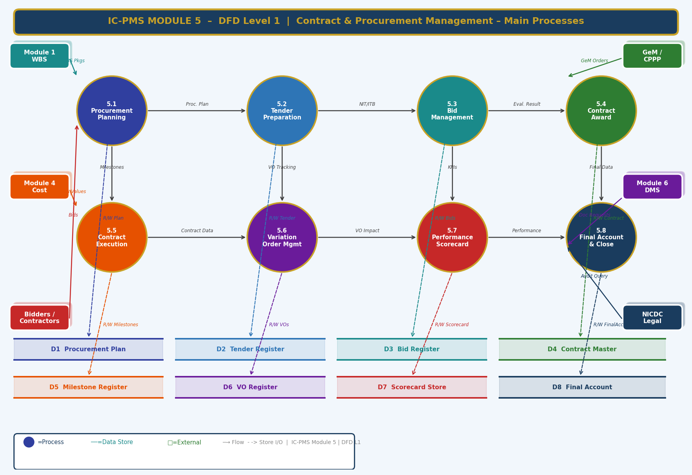
Figure 3.2 — DFD Level 1: Eight Core Processes and Eight Data Stores

Process and Data Store Descriptions
ID | Name | Primary Function | Key Stores
5.1 | Procurement Planning | Creates WBS-linked procurement plan; method selection; annual calendar; pre-qualification | D1 Procurement Plan
5.2 | Tender Preparation | Prepares NIT, BOQ, specifications, eligibility criteria; manages corrigenda; publishes to CPPP | D2 Tender Register
5.3 | Bid Management | Receives, evaluates (technical+financial), generates CS, checks IP, recommends L1 award | D3 Bid Register, D9 Evaluation, D11 IP Log
5.4 | Contract Award | Issues LOA, creates Contract Master, tracks PBG, processes advance, notifies unsuccessful bidders | D4 Contract Master
5.5 | Contract Execution | Monitors milestones, progress reports, NCRs, safety incidents, LD, correspondence | D5 Milestone Register
5.6 | Variation Order Management | Manages VO initiation, rate analysis, approval, GFR ceiling tracking, budget impact | D6 VO Register
5.7 | Performance Scorecard | Computes monthly 8-KPI contractor score; generates notices; feeds debarment register | D7 Scorecard Store
5.8 | Final Account & Closeout | Manages final measurement, Final Bill, retention release, NCC, dispute closure, archival | D8 Final Account

3.3 DFD Level 2 — Process 5.3: Bid Management (Exploded)
The Level 2 DFD drills into the Bid Management process — the most regulated and scrutinised stage in government procurement. Eight sub-processes cover the complete evaluation pipeline from NIT publication through comparative statement, integrity pact check (decision diamond), negotiation, and final award. This process must be executed in strict sequence with all decisions documented.
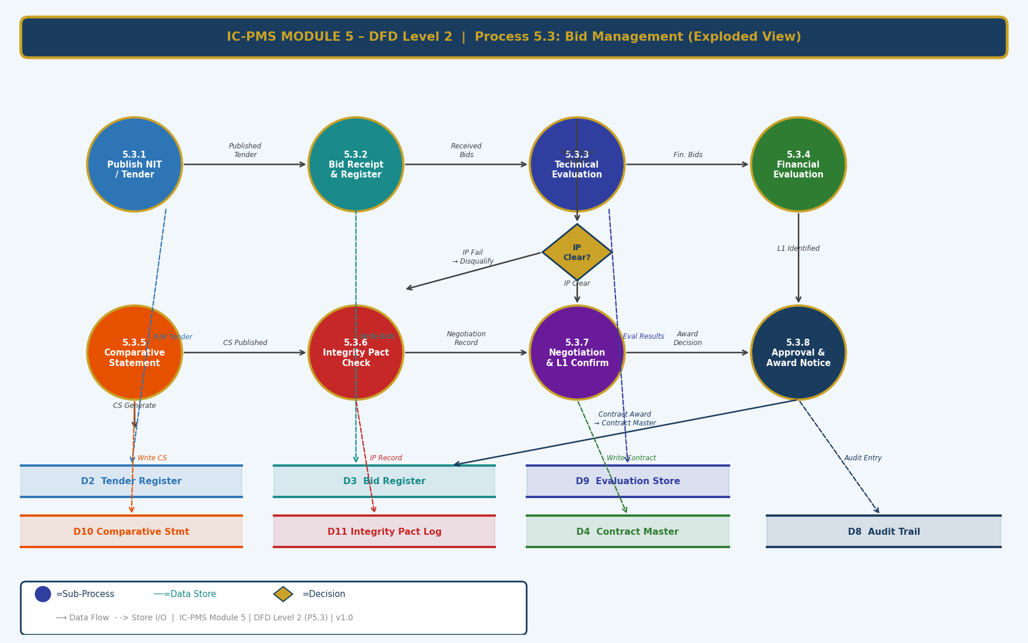
Figure 3.3 — DFD Level 2: Process 5.3 Bid Management — 8 Sub-Processes with Integrity Pact Decision Diamond

Sub-Process Narrative
Sub-Process | Name | Description
5.3.1 | Publish NIT / Tender | Finalised tender documents (from Process 5.2) published to CPPP via API. System generates unique tender ID, records publication timestamp, notifies pre-registered bidders, and sets bid opening date in system calendar. For GeM items, purchase request placed via GeM API.
5.3.2 | Bid Receipt & Registration | Bids received electronically via CPPP. Each received bid registered in D3 with: Bidder ID, submission timestamp, bid document reference. Late bids automatically rejected — system records rejection with timestamp. Bid opening committee (minimum 3 officers) records constituted in system.
5.3.3 | Technical Evaluation | Technical evaluation committee accesses bids. Each eligibility criterion evaluated with Yes/No + evidence reference. Scoring matrix (0–100) applied per criterion weight. Technical Qualified (TQ) / Not Technically Qualified (NTQ) status recorded for each bidder with mandatory written justification. All evaluations recorded in D9.
5.3.4 | Financial Evaluation | Financial bids of TQ bidders only are opened. Bid amounts recorded in D3. System ranks bidders by bid amount (lowest = L1). If L1 is > 10% above estimate, system flags for committee review before proceeding. Price variation analysis computed against estimate and prevailing market rates.
5.3.5 | Comparative Statement | Auto-generated Comparative Statement (CS) in CPWD format: bidder-wise technical scores, financial bids, deviations from BOQ, delivery/completion period, special conditions. CS reviewed and signed by evaluation committee. Committee recommendations recorded. CS stored in D10 and published to CPPP.
5.3.6 | Integrity Pact Check | For contracts > ₹10 Cr: System queries D11 (IP Log) for each TQ bidder. Checks: IP signed by authorised signatory, No pending IP breach investigation, IEM (Independent External Monitor) appointed. Decision diamond: IP Clear → proceed to negotiation; IP Fail → bidder disqualified; disqualification recorded with reason.
5.3.7 | Negotiation & L1 Confirmation | Negotiation meeting with L1 bidder conducted (if bid > estimate or committee requires clarification). Negotiation minutes recorded in system: original bid, negotiated amount, item-wise reductions agreed, compliance confirmation. If L1 walks away or is disqualified, process moves to L2 subject to committee approval.
5.3.8 | Approval & Award Notice | Award recommendation submitted through tiered approval workflow (SPV Director → NICDC MD for > ₹500 Cr → Ministry for > ₹1,000 Cr). On approval, LOA auto-generated and transmitted to L1 via CPPP + registered email. Contract Master created in D4. All bid-related records archived in D8.

4. Master Data Model

4.1 Entity Relationship Overview
The Module 5 master data model contains twelve entities. The Procurement Plan is the entry-point entity; the Tender Register, Bid Register, and Contract Master form the primary procurement-to-award pipeline. The Contract Milestone, VO Register, Contractor Scorecard, Final Account, Integrity Pact, Bank Guarantee, Dispute Register, and Evaluation Record are supporting entities that capture the full contract lifecycle.
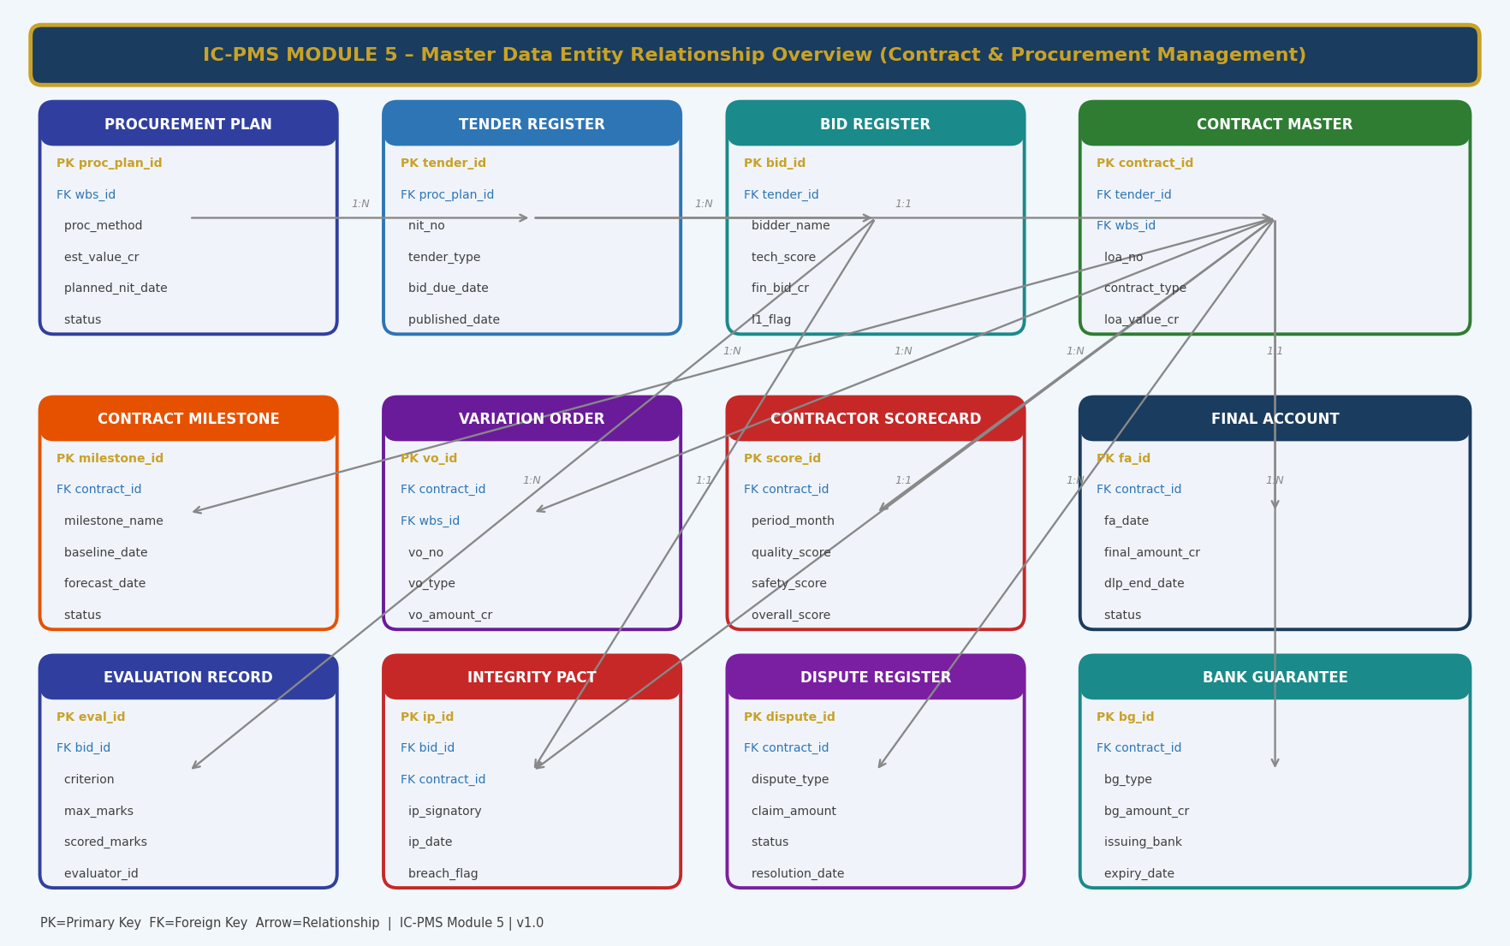
Figure 4.1 — Master Data Entity Relationship Overview (Module 5 — Contract & Procurement Management)

4.2 Core Entity Field Definitions

4.2.1 Procurement Plan
proc_plan_id | UUID — Primary Key
wbs_id | FK → Module 1 WBS Element — the work package(s) to be procured
proc_method | ENUM: OCT / LTE / GeM / Single_Source / EOI_then_ITB / Design_Build
contract_type | ENUM: Works_CPWD / Works_FIDIC_Red / Works_FIDIC_Yellow / Supply / Consultancy / PPP_Concession
est_value_cr | DECIMAL(15,2) — estimated contract value from WBS budget node
planned_nit_date | DATE — planned NIT publication date; linked to project schedule
planned_award_date | DATE — target LOA issuance date
pre_qual_required | BOOLEAN — true if EOI/RFQ pre-qualification stage required
integrity_pact_required | BOOLEAN — true if estimated value ≥ ₹10 Cr (mandatory)
bundled_wbs_json | JSONB — array of additional WBS IDs if multiple packages bundled
approved_by | FK → User — approving authority
status | ENUM: Draft / Submitted / Approved / NIT_Issued / Awarded / Cancelled

4.2.2 Tender Register
tender_id | UUID — Primary Key
proc_plan_id | FK → Procurement Plan
nit_no | VARCHAR — Official NIT number (NICDC/DMIC/PackageCode/Year-SerialNo)
tender_type | ENUM: Open / Limited / GeM / Nomination
bid_due_date | DATETIME — exact date and time of bid submission deadline
bid_opening_date | DATETIME — date/time of bid opening
published_date | DATE — date of CPPP / NICDC website publication
cppp_tender_id | VARCHAR — CPPP-assigned tender reference ID
gem_demand_id | VARCHAR — GeM demand number if procured via GeM
estimated_value_cr | DECIMAL(15,2) — confirmed estimated value at tender stage
emd_amount_cr | DECIMAL(15,2) — Earnest Money Deposit; 2% of estimated value, max ₹1 Cr
corrigendum_count | INTEGER — number of corrigenda issued; 0 if no amendments
pre_bid_meeting_date | DATE — date of pre-bid meeting; NULL if not applicable
tender_status | ENUM: Draft / Published / Pre-Bid / Closed / Evaluated / Awarded / Cancelled

4.2.3 Bid Register
bid_id | UUID — Primary Key
tender_id | FK → Tender Register
bidder_name | VARCHAR — registered legal name of bidding firm
bidder_gstin | VARCHAR — GSTIN validated against GSTN
submission_timestamp | TIMESTAMP WITH TIME ZONE — exact CPPP submission time
submission_status | ENUM: On_Time / Late_Rejected / Withdrawn
tech_eval_status | ENUM: Pending / TQ / NTQ
tech_score | DECIMAL(5,2) — total technical score 0–100
tech_disqualification_reason | TEXT — mandatory if tech_eval_status = NTQ
fin_bid_cr | DECIMAL(15,2) — financial bid amount in INR Crore
l1_flag | BOOLEAN — true if this is the lowest responsive bid
ip_status | ENUM: Signed / Not_Signed / Breach_Pending — Integrity Pact status
negotiated_bid_cr | DECIMAL(15,2) — bid amount after negotiation; NULL if no negotiation
bid_outcome | ENUM: L1_Awarded / L2_Reserve / Unsuccessful / Disqualified

4.2.4 Contract Master
contract_id | UUID — Primary Key
tender_id | FK → Tender Register
wbs_id | FK → WBS Element — primary scope
loa_no | VARCHAR — LOA number (NICDC/PackageCode/LOA/Year-SerialNo)
contract_type | ENUM — inherited from Procurement Plan
contractor_id | FK → Organisation Master (Module 1)
loa_value_cr | DECIMAL(15,2) — original LOA value
current_value_cr | DECIMAL(15,2) — LOA + all approved VOs
start_date / completion_date | DATE — contractual start and scheduled completion
dlp_months | INTEGER — Defect Liability Period in months (typically 12–24)
dlp_end_date | DATE — computed: completion_date + dlp_months
ld_rate_pct_per_day | DECIMAL(5,4) — LD rate as % of LOA per day of delay
pbg_received_date | DATE — Performance BG receipt date; advance blocked until set
advance_paid_cr | DECIMAL(15,2) — total advance paid (mobilisation + material)
contract_status | ENUM: Awarded / Active / At_Risk / Delayed / DLP / Closed / Terminated
fidic_book | ENUM: Red / Yellow / Silver / White / None — FIDIC conditions of contract

4.2.5 Contractor Scorecard
score_id | UUID — Primary Key
contract_id | FK → Contract Master
period_month | DATE — first day of the scored month
quality_score | DECIMAL(5,2) — 0–100; based on open NCRs
schedule_score | DECIMAL(5,2) — 0–100; based on Module 2 SPI
safety_score | DECIMAL(5,2) — 0–100; based on incident log
payment_score | DECIMAL(5,2) — 0–100; RA Bill submission timeliness
reporting_score | DECIMAL(5,2) — 0–100; weekly report submission rate
environment_score | DECIMAL(5,2) — 0–100; site audit findings
resource_score | DECIMAL(5,2) — 0–100; equipment mobilisation ratio
dispute_score | DECIMAL(5,2) — 0–100; frivolous claims ratio
overall_score | DECIMAL(5,2) — weighted average of all 8 dimensions
rating | ENUM: Excellent / Good / Satisfactory / Poor / Very_Poor / Critical
action_taken | TEXT — notices issued, meetings held, actions recorded this month

4.2.6 Integrity Pact Record
ip_id | UUID — Primary Key
bid_id / contract_id | FK — linked to both bid (pre-award) and contract (post-award)
ip_version | VARCHAR — IP document version (CVC standard format)
bidder_signatory_name | VARCHAR — authorised signatory from bidder side
bidder_sign_date | DATE — date of bidder signature
nicdc_signatory_id | FK → User — NICDC officer who countersigned
nicdc_sign_date | DATE — date of NICDC countersignature
iem_name | VARCHAR — Independent External Monitor appointed by CVC/NICDC
iem_appointment_date | DATE
breach_flag | BOOLEAN — true if a potential IP breach is under investigation
breach_description | TEXT — description of alleged breach (if breach_flag = true)
breach_resolution | TEXT — outcome of CVC/NICDC investigation
ip_status | ENUM: Active / Breach_Investigation / Resolved / Closed

4.2.7 Dispute Register
dispute_id | UUID — Primary Key
contract_id | FK → Contract Master
dispute_type | ENUM: Contractor_Claim / NICDC_Counter_Claim / EOT_Dispute / Rate_Dispute / Termination_Dispute
claim_amount_cr | DECIMAL(15,2) — amount in dispute
dispute_description | TEXT — detailed description of the dispute
contractor_position | TEXT — contractor's stated position
nicdc_position | TEXT — NICDC's stated position
dispute_date | DATE — date dispute formally raised
resolution_mechanism | ENUM: Amicable_Settlement / DRB / Arbitration / Court / Pending
arbitrator_name | VARCHAR — arbitrator/DRB member if appointed
award_amount_cr | DECIMAL(15,2) — arbitration award / settlement amount; NULL if pending
status | ENUM: Open / Under_Negotiation / DRB_Filed / Arbitration / Court / Settled / Closed
resolution_date | DATE — date of final resolution

5. UI/UX Screen Designs
Module 5 delivers five primary screens covering the main contract and procurement workflows. The module uses indigo as its identity colour (distinguishing it from the green of Module 4 Finance). Procurement and contract data are presented with a focus on action-orientation — the system always surfaces what needs to be done next, by whom, and by when. All screens support role-based visibility: contractors see only their own contract data; SPV PM sees all packages in their node; NICDC sees all corridors.

Screen 1 — Contract & Procurement Dashboard
The Dashboard provides a complete programme-wide view of contract health — active contracts by status, procurement pipeline by stage, pending critical actions (BG expiry, VO limit alerts, bid closings), and a live alert feed. It is the first screen opened by SPV contract managers and NICDC procurement officers each morning.
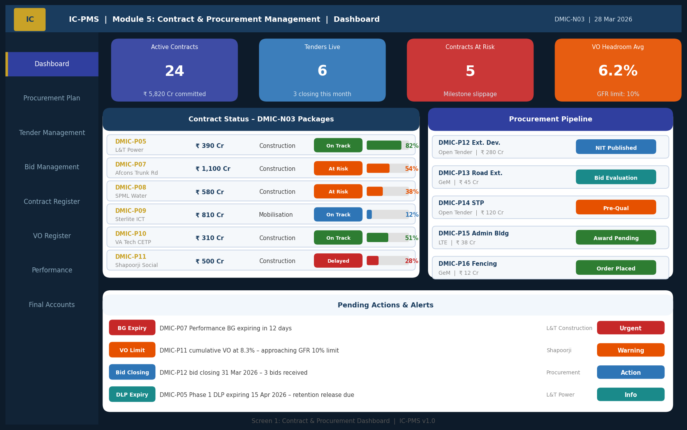
Figure 5.1 — Contract & Procurement Dashboard (KPI Cards, Contract Status Panel, Procurement Pipeline, Alerts)

Dashboard UI Components
Component | Description | Interaction
KPI Cards (4 — top row) | Active Contracts (count + total value), Tenders Live, Contracts At Risk, VO Headroom Average — colour-coded status | Click any card to navigate to filtered list view
Contract Status Panel (left) | Per-package contract row: contractor name, LOA value, phase, status badge (On Track/At Risk/Delayed), progress bar | Click row to open Contract Execution Monitor (Screen 4)
Procurement Pipeline (right) | Tender pipeline by stage: NIT Published, Evaluation, Pre-Qual, Award Pending, Order Placed — with procurement method and value | Click row to open Bid Management (Screen 3)
Alerts Panel (bottom) | Priority-sorted alerts: BG expiry, VO GFR limit approaching, bid closing, DLP expiry. Each with type badge, message, owner, and action button | Click alert to open relevant screen; action button = primary action (Renew BG, Submit VO, Review Bids)
Navigation Sidebar | 8 module links (Dashboard → Procurement Plan → Tender → Bid → Contract Register → VO → Performance → Final Accounts) | Active screen highlighted indigo with gold stripe

Screen 2 — Tender Preparation Wizard
The Tender Preparation Wizard is a 5-step guided workflow that ensures every mandatory element of a GFR-compliant tender package is completed before publication. The wizard prevents incomplete tender publications — a common source of CVC observations — by validating each step before allowing progression to the next.
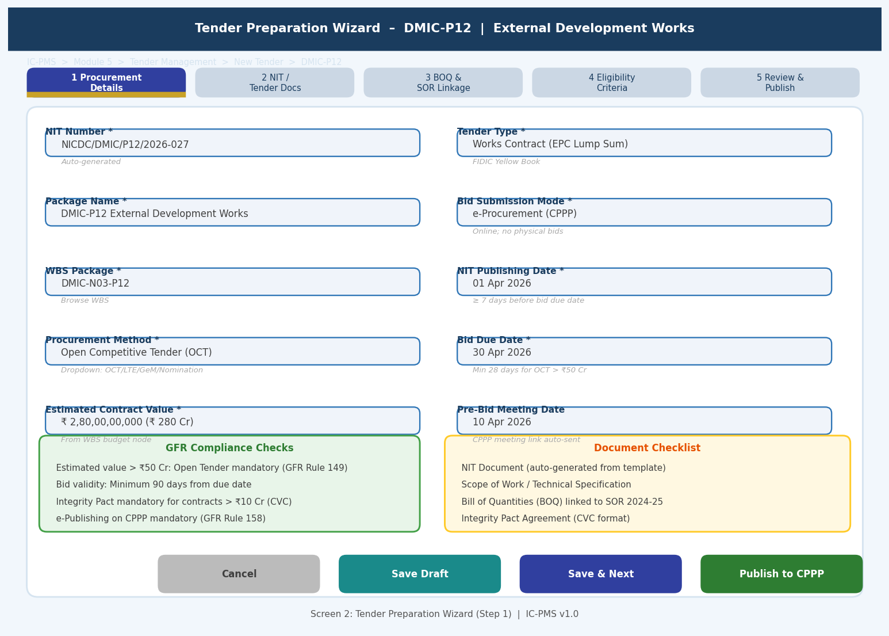
Figure 5.2 — Tender Preparation Wizard (Step 1: Procurement Details | GFR Compliance Checks | Document Checklist)

Tender Wizard Steps
Step | Title | Key Fields | Completion Gate
Step 1 | Procurement Details | NIT Number (auto), Package, WBS, Method, Contract Type, Estimated Value, Tender Type, CPPP mode, Dates | All mandatory fields; GFR compliance auto-checked
Step 2 | NIT & Tender Documents | NIT body (from template), Scope of Work, Special Conditions, Addenda, Pre-bid meeting arrangements | NIT document uploaded/generated; at least one scope document attached
Step 3 | BOQ & SOR Linkage | Line-item BOQ with SOR codes, quantities, units; DSR rate auto-filled; total estimated cost validated vs. budget node | BOQ total within ±5% of budget; all items have SOR reference or justification
Step 4 | Eligibility Criteria | Turnover criterion (min 3× annual contract value), Similar work experience, Key personnel, Equipment list, EMD amount | All criteria within GFR/CVC minimum requirements; IP mandatory check if value > ₹10 Cr
Step 5 | Review & Publish | Summary of all information; document hash preview; CPPP publishing confirmation; notification to registered bidders | SPV Director digital approval; system posts to CPPP via API; NICDC website simultaneously updated

Screen 3 — Bid Evaluation & Comparative Statement
The Bid Evaluation screen is the most governance-sensitive screen in Module 5. It presents all received bids in a matrix view for the evaluation committee — showing technical scores, financial bids, L1 ranking, IP status, and eligibility status. The Comparative Statement is auto-generated and signed digitally by all committee members within the screen.
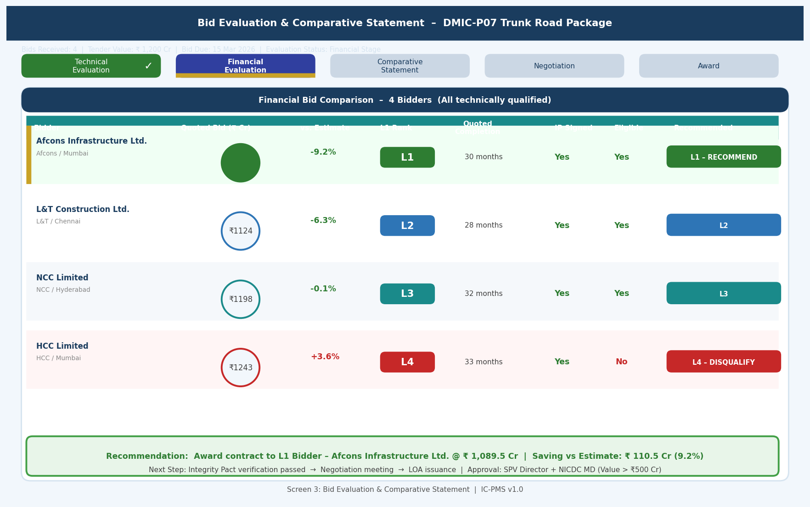
Figure 5.3 — Bid Evaluation Screen (Stage Tabs, Bidder Comparison Matrix, L1 Recommendation, Award Action)

Bid Evaluation Screen Design Principles
- Stage tabs: Horizontal progress tabs (Technical → Financial → CS → Negotiation → Award) show which stage is complete (green tick) and which is active (indigo highlight) — committee cannot access Financial tab until Technical is complete
- Gold border for L1: The lowest responsive bidder is automatically highlighted with a gold left border and circular bid amount indicator — immediately visible to committee without needing to hunt through data
- IP status column: Prominently shown for all bidders; red if IP not signed or breach pending; clicking the IP cell opens the IP register for that bidder
- Recommendation box: Fixed at the bottom of the screen — always visible regardless of scroll position; shows the system-generated award recommendation with basis; committee can endorse or override with documented reason
- Sealed evaluation: During Technical evaluation, Financial bids are cryptographically sealed and not visible; system enforces two-envelope process — technical evaluation committee cannot see financial bids until their evaluation is submitted and locked

Screen 4 — Contract Execution Monitor
The Contract Execution Monitor is the single-screen view of a live contract — combining the contractual milestone tracker, financial summary, and contractor performance scorecard in one information-dense but well-organised screen. PMC engineers and SPV PMs use this as their primary daily monitoring tool.
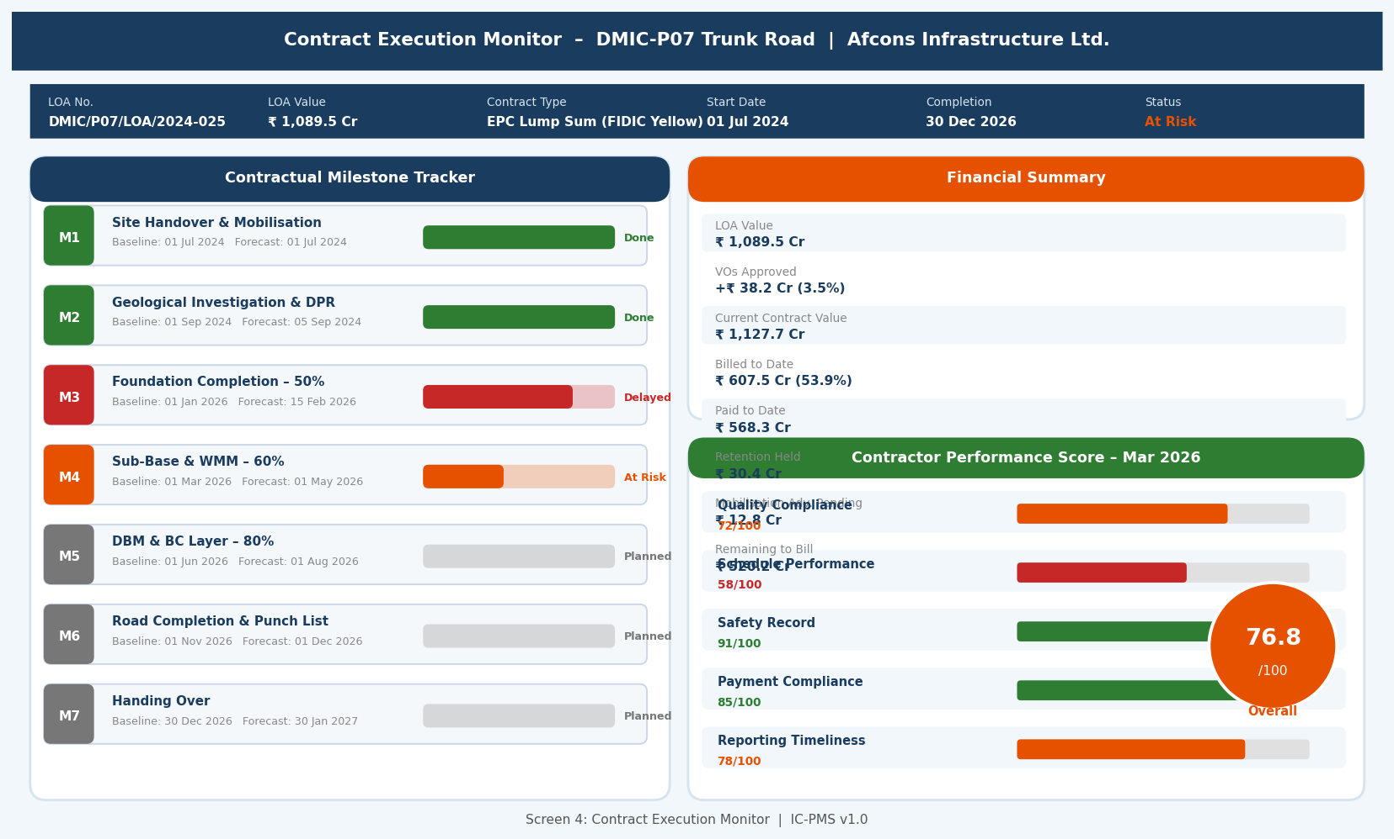
Figure 5.4 — Contract Execution Monitor (Milestone Tracker, Financial Summary, Contractor Performance Score)

Contract Monitor UI Components
Panel | Description | Key Interaction
Contract Header Strip | LOA number, LOA value, contract type, start/completion dates, status — always visible at top of screen | Status badge click opens contract status change workflow
Contractual Milestone Tracker (left) | 7-milestone Gantt with coloured status badges, baseline vs. forecast dates, progress bar, milestone ID | Click milestone to open evidence upload / completion certification form
Financial Summary (top right) | LOA value, VOs, current contract value, billed to date, paid to date, retention held, advance pending, remaining to bill | Each figure links to Module 4 for transaction detail
Contractor Performance Score (bottom right) | 8-KPI bar chart with current month's scores; overall score circular badge; month-over-month trend | Click any KPI bar to see detailed sub-criteria breakdown; click overall badge to open full scorecard (Screen 5)
Quick Actions bar | Issue Site Instruction, Raise NCR, Log Safety Incident, Request EOT, Issue Notice, Process RA Bill | Each button opens the relevant form without navigating away

Screen 5 — Contractor Performance Scorecard
The Scorecard screen provides the full multi-dimensional performance view of a contractor — a radar/spider chart showing all 8 KPIs visually, a 6-month trend chart showing whether performance is improving or declining, and a cross-contractor comparison table allowing benchmarking across all active packages. This screen is used by NICDC and SPV Directors for contractor performance review meetings.
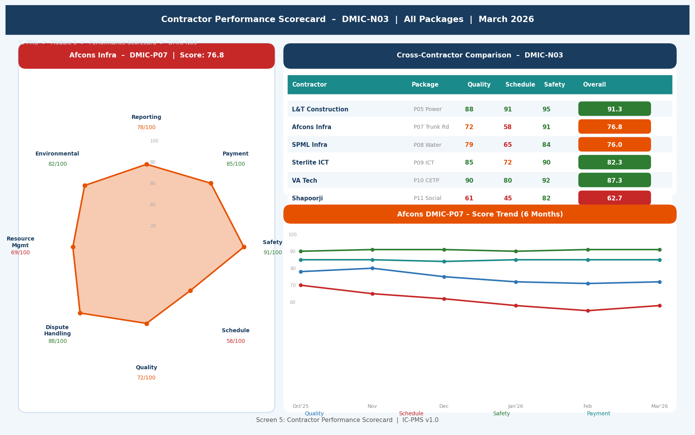
Figure 5.5 — Contractor Performance Scorecard (Radar Chart, Cross-Contractor Comparison, 6-Month Trend, Score Breakdown)

Scorecard Screen Features
Feature | Description
Radar Chart | 8-axis polygon spider chart showing current month's scores on each KPI. Filled orange polygon vs. grey reference circles at 20/40/60/80/100. Score labels at each axis tip with colour (Red<70, Orange<80, Green≥80).
Score Breakdown (axis labels) | Each axis label shows KPI name and current score. Clicking an axis opens the detailed sub-criteria breakdown showing exactly what drove the score (e.g., 'Safety: 2 minor incidents = -4 points').
Cross-Contractor Table | All active contractors in the node listed with their scores on Quality, Schedule, Safety, and Overall. Sorted by Overall score descending. Red-highlighted rows = score < 70 in any category.
6-Month Trend Chart | Line chart showing 4 key KPI trends (Quality, Schedule, Safety, Payment) over 6 months. Trend direction (improving/worsening) more important than absolute score. Declining trend lines shown in red.
Action Buttons | Generate Improvement Notice, Issue Show Cause Notice, Request Meeting, View Performance History — contextual actions based on current score rating.

6. Business Rules & Validation Logic

6.1 Procurement & Tender Rules
Rule ID | Description | Outcome
CON-001 | Procurement method must comply with GFR thresholds; Open Tender mandatory for Works > ₹25 Lakh; single-source requires documented justification and Cabinet approval | System enforces method vs. value mapping; override requires SPV Director + NICDC approval with mandatory justification text
CON-002 | For OCT above ₹2 Crore, NIT must be published on CPPP for minimum 28 days before bid due date (GFR Rule 158) | System blocks bid due date if < 28 days from NIT publication; corrigendum extending bid date does not reset the 28-day clock
CON-003 | Integrity Pact is mandatory for all contracts with estimated value ≥ ₹10 Crore | System blocks LOA issuance if IP status for awarded bidder is Not_Signed; IP must be executed before LOA transmission
CON-004 | Bid evaluation committee must have minimum 3 members; no member can have a conflict of interest with any bidder | Committee constitution recorded in system; any member flagging conflict of interest triggers automatic committee reconstitution workflow
CON-005 | Technical bids must be fully evaluated and locked before any financial bid is opened | System enforces two-envelope process; financial bids remain cryptographically sealed until all technical evaluations are submitted and locked by committee chair

6.2 Contract Execution Rules
Rule ID | Description | Outcome
CON-006 | Performance BG must be received within 28 days of LOA; advance payment blocked until PBG is confirmed | System blocks Module 4 advance payment until pbg_received_date is set in Contract Master; alert to SPV legal team from day 21
CON-007 | Sub-contracting limited to 49% of total contract value without explicit NICDC approval (standard NIT condition) | System computes cumulative sub-contracting value; alert at 40%; approval workflow triggered if 49% threshold approached
CON-008 | Liquidated Damages start accruing on the day after Scheduled Completion Date if work is not complete and no Extension of Time (EOT) is approved | System auto-computes LD from completion date; LD deduction auto-applied in Module 4 billing unless LD waiver approved in system
CON-009 | Extension of Time (EOT) can only be granted for Force Majeure, NICDC delays, or change in scope; contractor-attributable delays do not qualify | EOT request must include: reason code, supporting evidence, calculation of delay attributable to qualifying event; PMC recommendation mandatory
CON-010 | A contract cannot be Closed until: All milestones complete, All NCRs closed, Dispute register clear, NCC received, DLP period elapsed | System enforces all five conditions as blocking checks in contract closeout workflow

6.3 Scorecard & Debarment Rules
Rule ID | Description | Outcome
CON-011 | Monthly scorecard must be completed by PMC Lead and countersigned by SPV PM within 5 working days of month end | Alert to PMC Lead at day 3; escalation to SPV PM at day 5; RA Bill for that month held if scorecard not completed
CON-012 | A contractor scoring below 50 (Critical) for 2 consecutive months triggers mandatory debarment evaluation | NICDC MD notification; Debarment evaluation committee constituted; contractor notified in writing
CON-013 | A contractor who is debarred by Ministry of Finance (per Suspension and Debarment policy) cannot be awarded any IC-PMS contract | System validates new bidders against MoF debarment register via API; debarred entities blocked at bid submission stage

7. Integration Touchpoints

7.1 Internal Module Integrations
Module | Data Exchanged | Trigger / Frequency
Module 1 — WBS | Inbound: WBS work packages, estimated values from budget nodes, package scope; Outbound: Contract awards with LOA values linked to WBS, contractual milestone dates | On WBS Publish from Module 1; award trigger creates commitment entry in Module 4
Module 2 — Scheduling | Inbound: Schedule SPI per contractor WBS package (for scorecard); Outbound: Contractual milestone dates as schedule constraints | Monthly scorecard computation; milestone date updates trigger Module 2 constraint revision
Module 4 — Cost Management | Outbound: LOA values for commitment accounting, VO approvals with values, advance amounts, milestone payment schedule; Inbound: Payment confirmation for contract financial tracking | On LOA issuance; on VO approval; on each PFMS payment
Module 3 — Satellite | Inbound: AI progress % per WBS package — used to validate contractor progress claims in milestone reporting; Outbound: Contract polygon scope for satellite scene ordering | Weekly satellite run; real-time milestone completion verification
Module 6 — DMS | Outbound: All tender documents (NIT, BOQ, specs, corrigenda), LOA, VOs, Integrity Pact, correspondence, Final Account — auto-filed under WBS DMS folder | On each document creation / approval event
Module 9 — Reporting | Outbound: Contract status, procurement pipeline, VO summary, scorecard aggregate, pending BG/DLP data for executive dashboards | Real-time REST API read; refreshed daily

7.2 External System Integrations
System | Integration | Data Flow | Protocol
CPPP (Central Public Procurement Portal) | REST API — bidirectional | Tender publication, bid receipt, corrigendum posting, award notification, tender documents download | NIC CPPP API; OAuth 2.0; mandatory for OCT > ₹2 Cr
GeM (Government e-Marketplace) | REST API — bidirectional | Purchase request creation, GeM order placement, delivery confirmation, payment trigger | GeM Seller/Buyer API; session-based auth; GeM integration policy GFR Rule 149A
MoF Debarment Register | REST API — read | Bidder debarment status check before bid registration; contractor blacklist verification | Ministry of Finance API; checked on every new bid submission
GSTN | REST API — read | Contractor GSTIN validation and compliance status at bid evaluation stage | GSTN sandbox; 24-hour cache
Aadhaar / DSC (eSign) | REST / eSign API | Digital signature of evaluation committee members, LOA signing by SPV Director, IP countersigning | CDAC eSign API; DSC USB token integration for authorised officers
NICDC SMS / Email Gateway | SMTP / SMS API | Notifications to bidders (NIT publication, bid receipt, award, rejection), contractual notices | NICDC email gateway; SMS for milestone alerts and bid closing reminders

8. Workflow & Approval Chains

8.1 Contract Award Approval Chain
Contract Value | Level 1 | Level 2 | Level 3 | Notes
Up to ₹ 5 Cr | SPV PM | SPV Director | — | Two-level; DFA applicable
₹ 5–50 Cr | SPV Director | NICDC Programme Director | — | NICDC concurrence required
₹ 50–500 Cr | NICDC Programme Director | NICDC MD | — | NICDC MD as final authority
₹ 500 Cr – ₹ 1,000 Cr | NICDC MD | Ministry note (Secretary) | — | Ministry informed; Secretary-level concurrence
Above ₹ 1,000 Cr | NICDC MD | Ministry | CCEA approval | CCEA note mandatory; Cabinet approval for > ₹5,000 Cr

8.2 Bid Management Timeline (GFR Minimum Timelines)
Stage | GFR / CVC Requirement | IC-PMS Default | Alert Trigger
NIT publication to Bid Due Date | ≥ 28 days for OCT > ₹2 Cr; ≥ 14 days for LTE | 30 days OCT / 14 days LTE | System blocks if < GFR minimum
Bid validity period | Minimum 90 days from bid due date | 90 days standard; 120 days for large contracts | Alert to extend if award delayed beyond day 75
Technical evaluation completion | No GFR limit; CVC recommends < 30 days from opening | 20 working days from bid opening | Alert to committee head at day 15
Financial evaluation & CS | No GFR limit; CVC recommends < 15 days from Technical | 10 working days from Tech evaluation lock | Alert at day 8
Award after L1 determination | No GFR limit; Ministry guidance: < 30 days from CS | 21 working days from CS approval | Escalation to NICDC if not awarded by day 25
LOA issuance after approval | Within 7 days of final award approval | 5 working days | System auto-generates LOA on approval; alert if delayed

9. Performance & Non-Functional Requirements
Requirement | Specification | Measurement
Tender document generation | < 5 minutes to auto-generate full NIT + BOQ + eligibility from templates | Job completion time log
CPPP API publication | < 30 seconds from Publish action to CPPP confirmation | API call timing; alert if > 2 minutes
Bid evaluation matrix load | < 3 seconds for evaluation matrix with 10 bidders and 20 criteria | Lighthouse P95; load tested with 50 concurrent evaluators
Comparative Statement generation | < 30 seconds to generate auto-formatted CS for up to 20 bidders | CS generation job timer
Scorecard computation | < 10 minutes to compute all active contract scorecards at month-end | Monthly batch job completion time
Contract search | < 2 seconds full-text search across all active contracts by LOA number, contractor name, package code | Elasticsearch query time
Concurrent procurement users | 50 simultaneous bid evaluation committee members without degradation | k6 load test at 50 VUs during evaluation
Document storage | No size limit per tender package; 99.9% availability for tender documents during bid window | NIC MeghRaj object storage SLA
Audit trail completeness | Every user action logged with user ID, timestamp, IP, action type — no gaps | Monthly audit completeness check; VAPT test
Data retention | 30 years for all tender and contract records per GFR 2017 | Automated archival policy; cold storage after 7 years

10. Glossary — Module 5 Terms
Term | Definition
NIT | Notice Inviting Tender — public advertisement inviting bids for a contract
ITB | Instruction to Bidders — document setting out bid submission rules, evaluation criteria, and contract conditions
OCT | Open Competitive Tender — procurement method open to all eligible bidders; mandatory for Works contracts above ₹25 Lakh under GFR
LTE | Limited Tender Enquiry — procurement from a shortlisted panel of empanelled vendors; up to ₹25 Lakh under GFR
GeM | Government e-Marketplace — GoI's online procurement platform for goods and services; integrated with PFMS
CPPP | Central Public Procurement Portal — mandatory e-procurement portal for GoI tenders above ₹2 Crore
L1 | Lowest (1st) evaluated bidder — the technically qualified bidder with the lowest financial bid; normally awarded the contract
CS | Comparative Statement — tabular summary of all bids with technical scores, financial bids, and ranking; primary basis for award decision
IP | Integrity Pact — agreement between NICDC and each bidder/contractor committing to ethical conduct; mandatory for contracts > ₹10 Cr
IEM | Independent External Monitor — CVC-appointed independent person who monitors procurement for IP compliance
LOA | Letter of Award — formal document communicating contract award; creates legally binding obligations
PBG | Performance Bank Guarantee — financial security (typically 5% of LOA) against contractor performance failure
EMD | Earnest Money Deposit — bid security submitted with the bid (typically 2% of estimated value); forfeited if L1 withdraws
EOT | Extension of Time — formal approval extending the contract completion date for qualifying reasons
LD | Liquidated Damages — pre-agreed penalty for delay beyond Scheduled Completion Date
DLP | Defect Liability Period — post-completion period during which contractor must rectify defects; typically 12–24 months
NCR | Non-Conformance Report — PMC's formal record of a quality defect; must be closed before Final Bill
NCC | No Claim Certificate — contractor's written statement accepting Final Account and waiving all future claims
FIDIC | Fédération Internationale Des Ingénieurs-Conseils — international body issuing standard construction contract conditions (Red/Yellow/Silver Book)
DRB | Dispute Resolution Board — panel of neutral experts who adjudicate construction disputes; faster than arbitration

